Corporate Performance Report

KPI commentary

2022/23 Quarter 2

**Introduction**

This Quarter 2 2022/23 (Q2) report provides commentary on the Key Performance Indicators (KPIs) included in the [Corporate Performance Dashboard](https://app.powerbi.com/view?r=eyJrIjoiZDc1Mjk0ZWMtZjRkOS00MWJlLWE0ZTgtNzMwZTVkM2ZmNTdkIiwidCI6IjlmNjgzZTI2LWQ4YjktNDYwOS05ZWM0LWUxYTM2ZTRiYjRkMiIsImMiOjh9), including analysis and insight into performance and describing the action being taken to improve where necessary. It is presented in four sections aligned with the priorities of the council:

* Delivering better services
* Protecting the environment
* Supporting economic growth
* Caring for the vulnerable

Throughout the report the rating (RAG status) for each KPI is shown within the tables as:



Achieving the target/expected level of performance

 Slightly below desired level

 Requires improvement

The Corporate Performance Dashboard includes further information for each KPI, including:

* Latest performance summary
* Trend over time
* Detailed commentary on performance
* Definition
* Target and RAG thresholds
* Data sources

Instructions on using the Corporate Performance Dashboard are [here](https://app.powerbi.com/view?r=eyJrIjoiZjRiOGRlOTItMjYwNC00Nzc4LTg0ZjAtOTAyZjExYTJkNzcwIiwidCI6IjlmNjgzZTI2LWQ4YjktNDYwOS05ZWM0LWUxYTM2ZTRiYjRkMiIsImMiOjh9&pageName=ReportSection291af6ed1b315847ea53).

**Delivering Better Services**

This section reports on performance relating to the efficiency of our services in key areas and the council's use of resources.

Link to the Corporate Performance Dashboard: [Delivering Better Services Overview](https://app.powerbi.com/view?r=eyJrIjoiZjRiOGRlOTItMjYwNC00Nzc4LTg0ZjAtOTAyZjExYTJkNzcwIiwidCI6IjlmNjgzZTI2LWQ4YjktNDYwOS05ZWM0LWUxYTM2ZTRiYjRkMiIsImMiOjh9&pageName=ReportSection60bf4655b6f247d387ef)

**Percentage of parents receiving their preferred school places**

Performance remains on target and above benchmarks for pupils being offered one of their top three preferences at primary and secondary level with both in quartile two nationally. To achieve this:

* Publicity, including social media has reduced the number of late applications.
* Our website now shows levels of subscription for individual schools and maps of geographical priority areas.
* Officers attend open evenings for the most oversubscribed schools, and year 6 parent information sessions are held in the areas with the most pressure for places.

**Issues/causes:**

* Pressure for places has occurred where there have been unexpected levels of migration into Lancashire, particularly in Pendle, Burnley and Preston.
* More academies, free schools and faith schools, where governing bodies can determine how pupils are prioritised for places means that the published admission number can be decreased, despite objections.

**Actions:**

* The expansion of popular schools including Unity College (Burnley), Primet Academy (Colne) and Saints John Fisher & Thomas More RC High School (Colne). The number of places available for Year 7 pupils has been increased, as has the availability of places in higher year groups to accommodate in-year admissions.
* Consultations will be taking place in the Spring Term 2023 in respect of new primary schools and a secondary school in Preston.

**Take up of free funded Early Years education**

**Issues:**

* Although take up of free funded education for 2 year olds has improved and good performance for 3 to 4 year olds continues, challenges remain.

**Causes:**

* Parents altered working patterns during the pandemic and flexibility with hybrid working has reduced requirements for an early years' provider.
* Some cultural groups utilise wider family rather than formal providers
* We need to improve the commitment of some external stakeholders to improve take up of funded places.

**Actions:**

* Geographic and demographic areas of focus are in place to increase take up where current levels are below the county or national average.
* Working with the Best Start in Life Board to ensure that take up of funded places is a priority for all stakeholders.
* A multi-agency action plan has been in place since Summer 2021 to help improve the take up of funded places. Actions delivered include:
  + Raising awareness/campaign to encourage families to take up the offer.
  + Developing resources/toolkits to help promote take up.
  + Information sharing with services to target known families where children are not accessing a place.

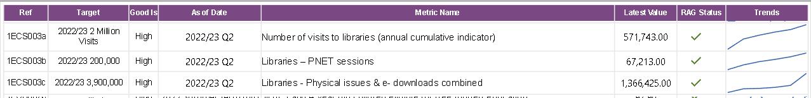**Use of Libraries**

**Issues/causes:**

* Although the use of libraries and their facilities has increased steadily, visitor numbers have only reached around two thirds of pre-pandemic levels.
* Public Network (PNET) sessions are less than pre-pandemic but are increasing.
* Physical issues remain at c.78% of pre-pandemic levels.
* Causes include the move of the Harris Library, Preston into temporary premises and the shift from physical loans to borrowing e-books/audio plus renewing online.

**Actions:**

* All libraries are broadening the scope of the offer for example, adult learning, craft club, board games club, seated exercise, school visits, knit and natter.
* We now provide free Wi-Fi, improved broadband and Wi-Fi printing.
* Digital support is offered in libraries.
* E-resources are being promoted, including e-newspapers and e-magazines and use has grown significantly in the second quarter.

**NoWcards Processing**

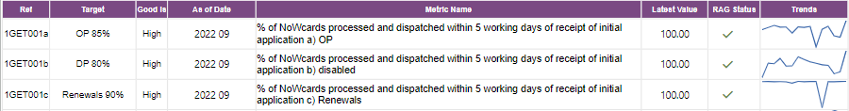

* Quarter 2 performance remains excellent and above target at 100%

**Safety carriageway defects**

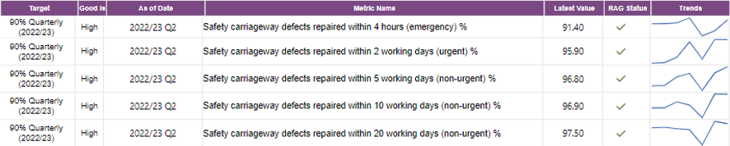

Good performance against all defect repair KPI's, to achieve this:

* Targeted additional training has been provided, including for the Customer Access Service.
* Emergency contact numbers have been re-published for all teams, which has helped reduce processing errors and improved the 4hr repair performance.
* The repair process for non-emergency repairs has been reviewed and improved, focusing on cost and time savings.

**Issue:**

* Defects numbers are starting to increase, which is expected during the Autumn/Winter period.

**Action:**

* Defect numbers will be closely monitored to understand and mitigate the impact on performance.

**Lighting (lamp out) faults**

Good performance in both non-traffic management and traffic management related lamp out faults, achieved by:

* Working with suppliers to ensure stocks are maintained where possible, enabling timely repairs to be carried out.

**Issue:**

* Autumn and winter brings an increase in reported lighting faults.

**Action:**

* Careful monitoring of impact on performance
* Continued close working with suppliers.

**Highway's safety inspections**



* Good performance in relation to Highway Safety Inspections with Q2 seeing the service comfortably exceed the KPI's targets. This has been assisted by reduced vacancies in the team and operating closer to capacity.

**Children with special educational needs/disabilities transported to school**



* Performance is on target, with staff demonstrating flexibility and working well.

**Customer access service**

**Issue:**

* The performance of calls answered decreased in quarter 2 and is below target.

**Causes:**

* This is due to reduced staffing resource in the current financial year with further staff turnover affecting quarter 2.

**Actions:**

* Performance improved in the second half of the quarter as staff have been replaced and trained.
* We are reviewing services delivered through Customer Access, improving information and allowing more self-service.
* More automated services are being explored and new ways of working piloted to improve resolution rates. These are expected to bring longer term benefits rather than short term improvements.

NHS Health Checks

**Issue:**

* All eligible residents were invited for a Health Check but only 35.6% received one.

**Causes:**

* The programme stood down nationally during Covid and restarted on 27th January 2022.
* Reduced capacity in General Practice/community providers to deliver due to Covid recovery.
* No relevant training has been provided to General Practice and pharmacy staff since 2020 due to Covid.

**Actions:**

* We are exploring how we can expand capacity as well as designing a training programme for all providers delivering NHS Health Checks, from various community venues including libraries and LCC buildings across the county. This will be rolled out in November 2022 to February 2023.
* The programme will also be delivered virtually as a refresher for those who have attended previous training.
* We are working with providers to increase uptake and develop community outreach models that will help reduce the variation in uptake. We are also working to improve the quality of the NHS Health Check offer.

**Tobacco control**

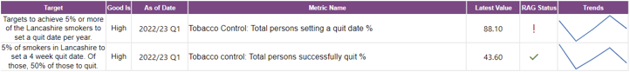

**Issue:**

* The number of smokers accessing the service has reduced compared to last year.

**Causes:**

* Less referrals during the pandemic – with only a telephone support service offered.
* Champix, a major GP prescribing option to treat tobacco addiction, has been removed from the national formulary. There were no referrals for Champix in Q1 2022/23 in comparison to 604 referrals in Q1 2021/22, which has therefore impacted on our overall referral rates.

**Actions:**

* We have focused on remobilising face to face community support this quarter.
* We are working with key partners to promote the revised service offer and increase uptake.
* We are implementing the national in-patient model to increase referrals from acute to community services.
* Promotional packs have been developed and distributed to GP practices where increased numbers of smokers have been identified.
* To mitigate the reduction in referrals due to Champix being removed from the national formulary, Nicotine Replacement Therapy will be promoted in accordance with national guidelines.
* A new electronic system will make referrals easier and provide outcomes information.

Health visiting service

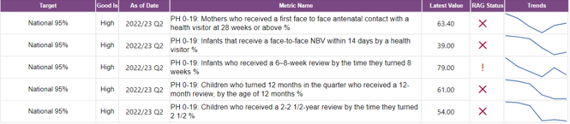

**Issue:**

* The national target of 95% is not being achieved across the service.

**Causes:**

* There are national issues affecting the health visiting workforce, with a high level of vacancies across the sector and increased staff sickness.
* We are experiencing the same issues, resulting in reduced capacity, which is affecting our ability to fulfil the mandated visits on time.

**Actions:**

* The service is prioritising targeted and specialist support to vulnerable families.
* New methods of recruitment and staff incentive schemes are being used.
* There is ongoing monitoring of sickness levels with a view to improve them.
* We are developing a better skills mix to address the staffing issues and are planning to integrate this service along with other children's services through the family hubs development programme.
* In addition, we are actively monitoring the recovery plan on a weekly basis and reviewing the service delivery to inform the design of the service model as part of our recommissioning programme scheduled during 2023/24.

**Sexual health services**

Although both KPIs show a slight decline in performance and issues remain, the service is generally performing well with both KPIs on target.

**Actions:**

* We are working with our provider to support primary care settings to increase workforce capacity.
* To continue improving Long Acting Reversible Contraception (LARC) uptake we are working with our provider to support GP practices to increase their capacity for LARC provision.

**Health and Safety in Lancashire's schools.**

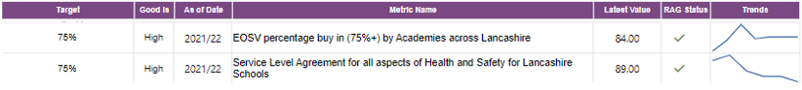

**\****EOSV = Educational off site visits*

Positive feedback from customers regarding the value of the services, and continued buy in above target levels, provides confidence in the current arrangements and developments.

**Issues:**

* The current levels of buy in from schools and academies ensures a high level of engagement with LCC Health and Safety and Educational Off Site Visits, these levels of engagement may, of course, reduce with further academisation as schools may choose to provide the services for themselves as a collective.
* The Service Level Agreement (SLA) arrangements and engagement gives us confidence in the safety provisions put in place within schools (for day to day and off site teaching) and enables us to have oversight and provide collective learning, development and best practice to the (SLA) schools in Lancashire. To help complete the assurance, schools not buying into the services are requested to complete a statement of their compliance in relation to the health and safety arrangements; this would also be requested by any further schools coming out of the comprehensive SLA arrangements to help provide us with some assurance of safe provision.

**Actions:**

* Further promotion of the services Lancashire wide (and some out of county near neighbouring facilities).

**Trading standards and scientific services**

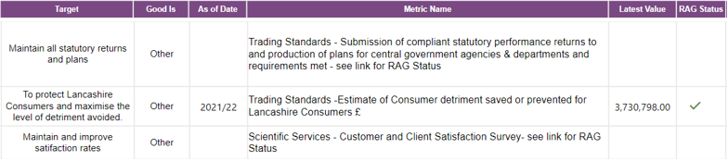

Trading standards has maintained compliant submissions of all required statutory returns. This has been achieved by:

* Engaging with relevant departments and agencies to ensure that we understand and deliver to their requirements.
* Identifying any changes to existing reporting requirements quickly and building them into the service data recording systems.

The KPI estimating the level of detriment which the service has saved consumers or helped them to avoid as a result of the service's activities is a new and developing KPI. We achieved this by:

* Responding to complaints and acting on intelligence.
* Taking timely enforcement or other action to deal with identified illegal or rogue practices.

Scientific services have maintainted or improved satisfaction rates where possible (with levels of satisfaction ranging from 94-100% across the range of questions).

Sickness absence in Lancashire County Council

75% of staff in quarter 2 had no sickness absence (9740 employees). This is a slight increase on 74% in quarter 1 and equates to 251 additional employees with no absence in quarter 2.

The graph below shows the trend in sickness absence since April 2021.

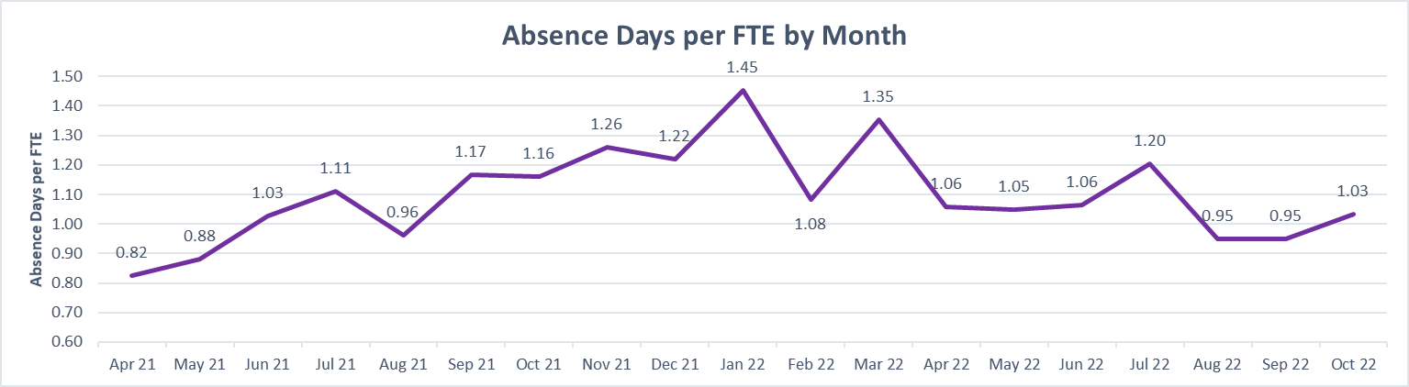

Issues:

* High sickness absence levels.
* High long-term absence.
* High mental health related absence (top reason for absence).

**Causes:**

* Inconsistent management action.
* Lack of performance targets.
* Limited monitoring of data and action planning.
* Impacts of COVID-19:
  + Cessation of monitoring and resetting targets reduced the ability to assess performance improvement.
  + Delays to treating pre-existing health conditions has extended sickness absence beyond what would have normally been expected.
  + Reduced occupational health capacity due to absences resulted in delays in providing support to enable sickness absence outcomes.
  + Mental health absence increased.

**Actions:**

* Performance targets have been reset to achieve a new council target of 8 days absence per FTE employee, this is a 4-year stretch goal to be achieved by 2025/26 to be in line with current comparators.
* Detailed data dashboards to determine actions and interventions are provided to all services on a monthly basis.
* Improving access to relevant comparator data.
* Services are expected to use the data dashboards to determine actions and interventions to improve outcomes and produce action plans.
* Corporate enabling support is in place through Human Resources, Business Intelligence, Public Health, Health and Safety and Learning and Development.
* Long term sickness absence is subject to weekly review. Long term sickness absence days per FTE have reduced by 17.8% for Q2 2022/23 when compared with the same period last year. The primary reduction has been in Mental Health. Recent weekly data analysis trends have shown a reduction in absences that are over 100 days with 62 closing.
* Improved wellbeing offer, through targeted intervention including access to an Employee Assistance Programme and service specific wellbeing actions through sickness absence data intelligence.

Budget Monitoring

The 2022-23 revenue monitoring position as at Quarter 2 (Month 6) is a forecast overspend of £7.989m, which by way of context is 0.84% of the county council's net budget. This is a significant improvement compared to the position reported to cabinet at Q1 where a £17.740m overspend was predicted. The main reasons for improvement are additional income in Adult Services and a reduced overspend on placement costs in Children's Social Care. Further details are included in the Money Matters Report to Cabinet in December.

**Protecting the Environment**

This section reports on the work being undertaken to protect our environment, both by providing services to Lancashire's citizens and by improving the environment footprint of the council's services.

Link to the Corporate Performance Dashboard: [Protecting the environment overview](https://app.powerbi.com/view?r=eyJrIjoiZjRiOGRlOTItMjYwNC00Nzc4LTg0ZjAtOTAyZjExYTJkNzcwIiwidCI6IjlmNjgzZTI2LWQ4YjktNDYwOS05ZWM0LWUxYTM2ZTRiYjRkMiIsImMiOjh9&pageName=ReportSection5dc87da89f468477f9b6)

**Waste management**

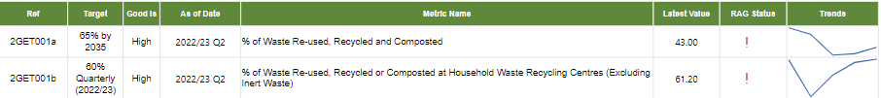

**Issues:**

* The amount of recycling collected in the first five months of this year is down by 5,000 tonnes compared to the same period in 2021/22. Doorstep collected residual waste dropped by 6,040 tonnes over this period. This is in the context of total annual arisings of circa 100,000 tonnes of collected recycling and circa 300,000 tonnes of collected residual waste.
* The 65% target for the first KPI is taken from the Government's Resources and Waste Strategy 2018. Formal targets will follow from the Environment Act 2021 and were the focus of a government consultation earlier this year, the outcome of which has not yet been published.

**Causes:**

* Generally, waste arisings went up during the pandemic and have since been falling. The overall recycling rate, as a percentage of waste arising, has remained consistent.
* A reduction in performance was witnessed at Household Waste Recycling Centres (HWRC) in the last two years largely because staff were not able to engage with the public or handle waste items during the pandemic.
* The final HWRC recycling rate for Q1 was 60.4%. The average rate for July and August was 61.2% - September (& therefore Q2) figures are not due to be available until the end of November. The KPI is currently rated as Amber as we get a higher volume of garden waste in spring and summer therefore performance is likely to drop in subsequent months.

**Actions**

* On the 1st June 2022 a new contract commenced increasing Refuse Derived Fuel output from Thornton Waste Recovery Park from 65,000 tonnes to 75,000 tonnes per year, securing an outlet for this waste stream for the next 3 years.
* Earlier this year HWRC supervisors were given targets for the improvement of recycling performance and a number of measures put in place to support this.

**Lancashire County Council's vehicle fleet**

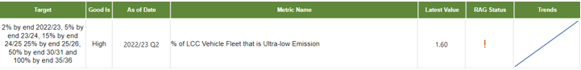

**Issues:**

* The very much higher capital purchase costs for Ultra Low Emission Vehicles (ULEV), particularly for minibuses and larger vehicles along with frequently very high costs in providing charging infrastructure is an important consideration.
* The limited availability in the market of cars, vans and all other vehicle types is affecting the fleet replacement programme and there are a greater number of vehicles that have been retained on hire.

**Causes:**

* Current market availability of vehicles and lead times.

**Actions:**

* The service continues to assess the opportunities to acquire ULEV vehicles and has received a number of new vehicles into the fleet recently. 12 electric cars and one van have been received in the six months to 31 October 2022.
* Consideration is being given to making permanent the arrangement that is in place for 2023/24 and 2024/25 whereby orders can be placed in advance of the current fiscal year.
* The roll-out of charging infrastructure will facilitate the practical introduction of more electric vehicles.

**Supporting Economic Growth**

This section reports on the council's activities to support new businesses, including the development of infrastructure and, recognising the importance of knowledge and skills development, educational attainment.

Link to the Corporate Performance Dashboard: [Supporting economic growth overview](https://app.powerbi.com/view?r=eyJrIjoiZjRiOGRlOTItMjYwNC00Nzc4LTg0ZjAtOTAyZjExYTJkNzcwIiwidCI6IjlmNjgzZTI2LWQ4YjktNDYwOS05ZWM0LWUxYTM2ZTRiYjRkMiIsImMiOjh9&pageName=ReportSectionb70fc96b9650bdfa9861)

**Educational attainment**

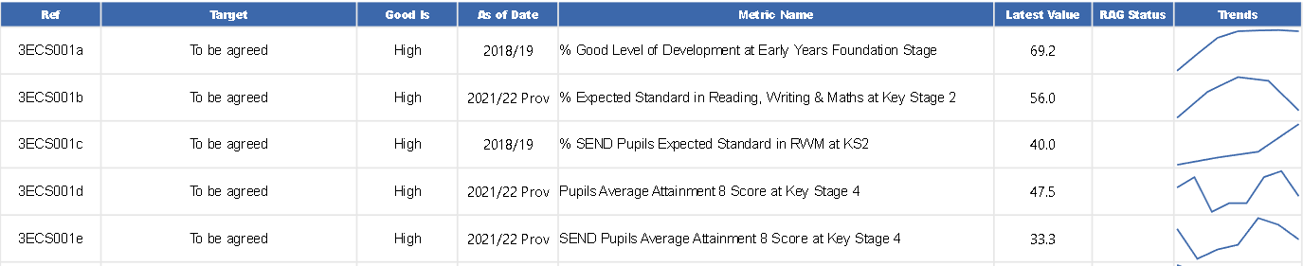

Published Data for Early years Foundation Stage will be available late November 2022

**Key Stage 2 (years 3 to 6 in primary school)**

**Issue:**

* Following two years of cancellations of assessments at Key Stage 2 during 2019/20 and 2020/21, provisional data has been published for 2021/22.
* Lancashire is ranked 110 of 150 authorities for the percentage of pupils reaching the expected standard in reading, writing and maths at KS2.
* The attainment gap between genders remains, with girls (59.9%) outperforming boys (51.6%).

**Causes:**

* Lancashire experienced a high impact from the COVID-19 Pandemic, with primary school absence rate being higher than the national averages. During 2020/21, there were 72 full closures of primary schools. Research by the DfE suggest pupils with higher attainment at KS2 and KS4 had lower levels of absence over the key stage compared to those with lower attainment.
* It is however worth noting that OFSTED outcomes from primary school inspections, after the pandemic have continued to be Good, highlighting the work that schools have done to provide high quality education and stability for children during such an unprecedented time.

**Actions:**

* Provision of a large range of courses/support sessions to schools covering all aspects of Key Stage 2 Attainment and Progress.
* Consultants working with schools over a period to improve outcomes.
* Lancashire Professional Development Service works with clusters of schools.
* Reviewing our offer and ensure we are offering training in those areas of locality that most need it.
* Providing support for schools in difficulty.
* Delivering Education Endowment Foundation work focused on children in the East of Lancashire where data shows highest need.
* Delivering a range of programmes, including several which focus on improving attainment by boys.

**Key Stage 4**

**Issue:**

* This academic year saw the return of the summer exam series, after they had been cancelled in 2020 and 2021 due to the impact of the COVID-19 pandemic where alternative processes were set up to award grades. The 2021/22 results are not comparable to the previous two years.
* Provisional KS4 attainment 8 score data of 47.5 ranks Lancashire as 84 of 151 authorities compared to a score of 46.7 and ranking of 63 of 150 authorities for 2018/19.
* For the pupils with special educational needs or disabilities provisional KS4 attainment scores increased from being 32.5 in 2018/19 to 33.3 in 2021/22. However, Lancashire's ranking dropped to 93 of 151 authorities in 2021/22 from being 68 of 150 authorities for 2018/19.

**Causes:**

* The COVID-19 pandemic has had a substantial impact on Lancashire resulting in school or class closures, supply staff covering absent teaching staff. Data for secondary schools also shows that Lancashire has consistently higher rates of absence due to Covid than the national figures. A DfE White Paper says: "Children with no absence at key stage 4 are almost 2 times more likely to achieve 5 or more GCSEs than children who missed 10-15 percent of lessons"
* No schools were inspected during COVID-19, but following the Pandemic, initial inspections have showed that most schools have remained Good or Outstanding, suggesting a continued drive on school improvement through the pandemic.

**Actions:**Delivering learning and collaboration opportunities for schools.

* Providing high quality training for governors to enable governing boards to robustly challenge and hold school leaders to account.
* Working closely with partners to ensure maintained schools receive the support they need to improve.
* Enhanced traded offer including consultancy in English, Maths and Science for mainstream, special and alternative provision settings.
* Close working with the Inclusion service in their development of the Alternative Provision strategy for all schools.
* Encouraging school to school support including facilitating the network for Outstanding schools and promoting funded offers from the DfE.
* Team Around the Schools and Settings – partner approach to improving outcomes for young people and children. Priority areas and focus pieces of work include attendance, exclusion, trauma informed practice.
* Education Recovery Group established during the pandemic and continuing to meet monthly, covering wider topics. This group provides feedback on the key areas needing support from us.

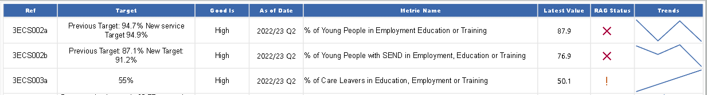16/17**-year-olds and care leavers in Employment Education or Training (EET).**

**Issues:**

**16/17 year olds**

* Compared to quarter 2 for 2021/22, performance has dipped for both measures.
* It is worth noting that there are more young people actually in employment education or training than reported in the same quarter last year (4.1% increase), but the increased cohort size means the KPI is reporting a lower percentage.

**Care leavers**

* At the end of September 2022, 303 of the 604 care leavers aged 18-20 were in Employment, Education or Training (EET), which, whilst showing improved performance is still below target.

**Causes:**

**16/17 year olds**

* There has been a 4.4% increase (1,184) in the number of young people aged 16-17 in the cohort for this KPI, increasing workload at a time when resource capacity is an issue.
* Some educational establishments are yet to share the destinations data.
* EET figures do traditionally reduce over the summer period as young people complete college/university courses and are being supported to plan their next move.

**Care leavers**

* Young people who are care leavers have told us they are very anxious about ceasing benefit claims when starting work, particularly when the employment they are accessing, on zero hours contracts for example, don't pay enough to meet essential living costs.

**Actions:**

**16/17 year olds**

* To increase staffing and resources capacity additional staff will be trained from December.  This will provide additional resources in the new year.
* Improved engagement with relevant services will ensure more timely data sharing takes place going forward.

**Care leavers**

* Children's services run PACT meetings (Performance, Audit, Challenge and Track) to ensure performance is closely monitored across all service areas. Care Leavers in employment education or training EET will continue to be a regular focus of these meetings, with the Employment Support Team attending.
* We are working with Lancashire's colleges to support our young people to remain in college.
* EET is a focus at the Corporate Parenting Board, with a dedicated workstream.
* Individual pathway planning ensures education, employment and training opportunities are fully explored.

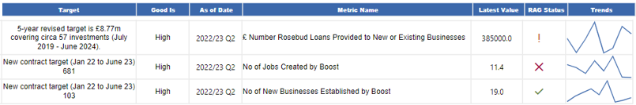**Supporting new businesses and business growth**

**Issues:**

* Against the current KPIs for our work around the council's economic prosperity we are still seeing a diminished appetite for investment via Rosebud and less new business starts and new jobs arising from business support activities.

**Causes:**

* The forecasted outturn for Rosebud this quarter was expected to be higher however continued economic uncertainty delayed some deals from progressing further. Nonetheless the total Rosebud investments so far this year have reached £887k across 8 deals.
* Start-up and job creation figures remain weak. We believe this is a result of a failure of delivery partners to adapt to new markets and realign their service after the pandemic. The new and re-commissioned delivery partners that we work with (new programme started in Jan 2022) have struggled to deliver the number of business-starts and business support interventions that we had forecast. We would have expected to see some uplift in new business start support as the pandemic has prompted a trend towards career change.

**Actions:**

* Current pipeline sits at £1.5m heading into the 3rd quarter. A longer-term review of the positioning of Rosebud was presented to Lancashire County Developments Limited (LCDL) Board in September and a task and finish group has been established to consider if and how the fund continues.
* The Business Growth Service is now in the process of terminating the contract for the organisation providing our pre-start business support and have asked for detailed recovery plans from the same contractor on post start-up and scale-up business support. We will seek to replace the service which has been terminated with a more effective, lower-cost solution, starting in the new year.

**Caring for the vulnerable**

This section includes performance about our adult social care services, support to children, young people and their families, and public health.

Link to the Corporate Performance Dashboard: [Caring for the vulnerable overview](https://app.powerbi.com/view?r=eyJrIjoiZjRiOGRlOTItMjYwNC00Nzc4LTg0ZjAtOTAyZjExYTJkNzcwIiwidCI6IjlmNjgzZTI2LWQ4YjktNDYwOS05ZWM0LWUxYTM2ZTRiYjRkMiIsImMiOjh9&pageName=ReportSection489c7625386fd097c262)

**Adult Social Care Services**

This section is divided into 4 areas to reflect the Service Plan for adult social care services: shaping the market, making the right impact, promoting independence and choice, and financial sustainability.

***Shaping the market***

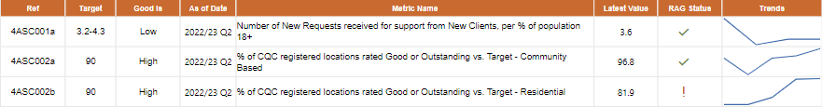

**Number of New Requests for support from new clients per % population 18+**

**Issues:**

* Requests for support from adult services are lower than that of comparator authorities, and this is based on the latest available comparator data from 2021/22.
* There has been a slight increase from last years’ figure, but this is consistent with England and our comparator Local Authority averages.

**Actions:**

* We are further developing our understanding of our population needs through our Social Care reforms and Living Better Lives in Lancashire programmes, which support us to understand and offer a range of signposting options which vary according to where the service user lives.
* Our aim is to enhance and shape the market to enable people to find good quality, local support without needing to contact the council directly. We have set a target range of 3.2 (which was the best performing Local Authority) and 4.3 (which was the England average).

**Care Quality Commission - Residential home & Community Based Services**

**Issues:**

* We are currently below the target (81.9% against 90%) in relation to residential care homes rated as good or outstanding by the Care Quality Commission (CQC).
* Community-based services are currently well above target (96.75% against 90%).

**Causes:**

* Our home care framework requires commissioned community providers to be rated as good or outstanding at the onset of issuing the contract, this is the main reason why performance in this area is strong.
* In the care home sector, we will commission places from providers with differing CQC ratings – outstanding, good or occasionally requires improvement – based on an individual's choice. We have a strategy to improve care home ratings by supporting them to make improvements. Analysis from the quality team has highlighted common themes in relation to financial issues, lack of leadership and workforce issues which have been more acute following the pandemic. We are working to support providers to make the improvements in these areas.
* Of the 36 services directly provided by Lancashire County Council, 32 are graded as ‘good’ or ‘outstanding’.  None are ‘inadequate’ but four older people’s residential homes are judged as ‘requires improvement’ and robust improvement plans are in place.

**Actions:**

* Regarding both residential homes and community-based services, we work very closely with providers to maintain and improve standards and ensure the delivery of quality services to our vulnerable citizens.
* With specific regard to residential homes, a recovery plan is in place to continue this support. However additional challenges are now facing the sector which include a significant loss of workforce and increased costs associated with the cost-of-living crisis. Some providers are making the difficult decision to exit the market.
* Robust improvement plans are in place, in readiness for the next inspections, for the 4 older people's residential homes provided by Lancashire County Council that are graded as ‘requires improvement’.
* We are working with the NHS locally and nationally to support providers with the current challenges they face. This includes supporting providers with improvements and developing a longer-term plan ensuring that we only commission good quality care.

**Size of Care Market Workforce**

* This indicator is under review.

***Making the right impact***

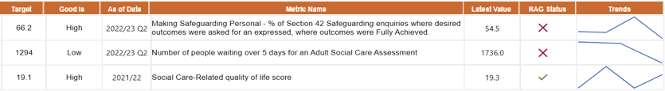

**Making Safeguarding Personal - % of safeguarding enquiries where desired outcomes were asked for and expressed, where outcomes were fully achieved.**

**Issue:**

* The ‘Fully Achieved’ performance has dropped since the last quarter (68.1% to 54.5%).

**Causes:**

* We have introduced different ways of working ensuring the principle of making safeguarding personal is embedded in practice and the individual only has to tell their story once. Whilst we are confident that this is happening in practice, the inputting of data needs to be more robust to ensure we meet the above set targets.

**Actions:**

* Managers continue to support staff with practice but will also robustly audit records and analyse the data to ensure we are on a trajectory to achieve the target

**Number of People waiting over 5 days for an assessment**

**Issues:**

* Ideally, no one who contacts Adults Social Care should wait more than 5 days for the start of a proportionate level of assessment.
* We have prioritised those waiting more than 6 months and have had success with this. As a consequence of this prioritisation, our reported 5 days target figure has moderately reduced from 1852 in Q1 2022/23 to 1736 Q2 2022/23. Although this demonstrates progress, further work is taking place to achieve the target.

**Causes:**

* More people are contacting Adult Social Care for an assessment and urgent support.
* Staffing capacity challenges have been experienced, particularly in services for older people and people with physical disabilities.

**Actions:**

* Targeted work continues to address the waiting lists for a social care assessment.
* Significant progress has been made around reducing the number of people waiting longer than 6 months for an assessment. This will allow us to more effectively focus on those waiting over five days for an assessment.
* Weekly reviews take place to closely monitor the performance. Teams are focussed on reducing the numbers as well as keeping length of time people have to wait down.
* Further work is underway to develop a measure which focuses on the timeliness of assessment completion, as this will be a complimentary indicator in terms of reporting on our overall responsiveness to people in need of support.
* Our timeline for achieving the target is end of the financial year 2022/23.

**Adult Social Care Related Quality of Life survey**

* This KPI helps to demonstrate that services provided by adult social care are supporting people to maintain their quality of life.
* It is an annual survey of people receiving services from adult social care in Lancashire, and in 2021/22 resulted in a quality-of-life score of 19.3.
* The latest national benchmarking figures are from 2019/20 (not updated due to the pandemic) and at that point the England average was 19.1 and the Northwest regional average was 19.2.

**Actions:**

* In addition to the survey, we are implementing an Adult Social Care Quality Assurance and Improvement Framework (scheduled from January 2023), which will collate service user data in two key areas:

1. Improved health and well-being outcomes.

2. Experience of the quality-of-service delivery.

**Proportion of people waiting 28 Days or more for a package of care**

* We are considering the timeframe of this indicator so this will reflect the service experienced by our users. At this stage we have not set a target, but it is clear that 'good' will be low. We will look to provide data, with some historical trends, in the next report.

**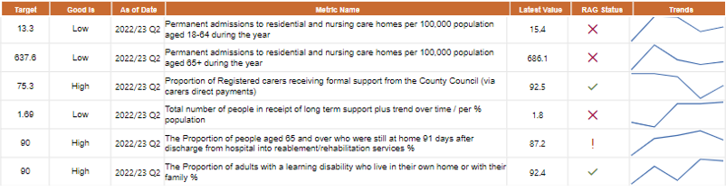*Promoting independence and choice***

**Permanent admissions to residential and nursing care homes per 100,000 population aged 18-64 and aged 65+ during the year**

**Issues:**

**Adults 65+**

* In this age band we have seen an increase from Q1 (677.91) to Q2 (686.13). Despite this increase we can see that this is lower than in previous years (2015-2019) which consistently ranged between 711 & 742.
* We aim to continue our overall downward trend and have set a target of 637.6, which we consider to be realistic when considering the challenges we often face with sourcing non-residential care, with cost-effective providers.

**Adults 18-64**

* In this age band there has been an increase from Q1(14.75) to Q2 (15.45), although it remains lower than in Q4 of 2021/22 (16.9), It is higher than the 20/21 comparator (nearest neighbour) average of 12.19.
* We have seen an increase in demand for mental health placements and for young people with complex needs.

**Causes:**

* Specialist staff shortages and lack of non-residential care provision can result in there being little alternative to support a discharge from hospital than a residential placement.
* Residential admissions slowed during the main part of pandemic but since the rate of admissions has started to increase.

**Actions:**

Several initiatives are in place with the intention of avoiding admissions and reducing the number of people in residential care across both age bands above. These include:

* Senior Management oversight at the Complex Case Forum
* Reviewing the intermediate care offer
* Commissioning of good quality housing with support for people
* Positive Ageing Trailblazer (to support short term placements following hospital admission with a home first approach). Early indications are the Trailblazer is having a positive impact.

**Proportion of registered carers receiving formal support from the County Council**

* We aim to maintain our current high levels of performance. Particularly worthy of note, is direct payments to carers have proved to be much more efficient and promote independence and choice.

**Total number of people in receipt of long-term support per % of the population aged 18+**

**Issue:**

* We provide more people with long term support (per head of population) than our nearest neighbour authorities.

**Causes:**

* Insufficient focus on community and individual assets means that people are being drawn into the formal care system, who otherwise could have been dealt with through accessing universal and community services.
* Some people have waited too long for an assessment (particularly during the pandemic) and this means they developed more complex needs and therefore required formal support.

**Action:**

* The introduction of self-assessment and sign posting to community services and increasing our digital offer to promote self-reliance and independence.
* Backlogs have significantly reduced, and this will allow for earlier interventions and reduce long term needs. The backlog work is due to be completed in February 2023.
* The Living Better Lives in Lancashire Programme will gather momentum this Autumn/Winter and will support an improvement in our performance over time, as we progressively promote increased independence by better use of community support.

**The proportion of people aged 65 and over who were still at home 91 days after discharge from hospital into reablement/rehabilitation services**

**Issue:**

* We aim to continue our comparatively high performance and move closer to the 90% target. However, this will prove challenging, as we will be increasingly working with service users with more complex needs.

**Actions:**

* Continued close monitoring of service user outcomes
* Significant work has been undertaken to improve the operational flow of the Reablement Service and improve the quality of provision to people to achieve better outcomes and promote their independence.
* A review of both the reablement service and the wider Intermediate Care provision continues to inform future operational delivery and the re-procurement of the service which is due by the end of 2022/23.

**Proportion of adults with a learning disability who live in their own home or with their family**

* We continue to be a top performer (when compared with our 'nearest neighbours') with an upward trajectory.

**Actions:**

* The work being undertaken to deliver on the ‘Housing with Care and Support’ Strategy 2018-25 has strengthen our approach to working with providers, developers and partners.  This includes working closely with the district councils.

***Financial sustainability***



**Long term support average cost per person per week**

**Issues:**

* Although we are currently maintaining our expected performance, we are seeing an increase in the number of homecare packages sourced off framework due to capacity issues of providers on the current framework. These are usually at a higher cost than framework providers and will impact on budget.
* We are unable to increase the number of providers on the current framework due to procurement regulations.
* Pressures within the NHS, particularly discharge arrangements, are driving up the average costs. This is as a consequence of the NHS directly procuring care at a higher cost. This is one of the issues we are working closely with our NHS colleagues to address, and we are developing a pilot approach to joint commissioning with a number of providers.
* It is also unclear how the ‘Fair Cost of Care’ exercise and future uplifts will impact on cost.

**Actions**

* The Homecare Tender due to go out for procurement in March 2023 will address the issues relating to the current homecare framework.
* We are monitoring the position in relation to 'Fair Cost of Care' and are developing appropriate mitigating actions.

**Children and families**

**Children and Families Wellbeing Service**.



**Issue:**

* The percentage of children and young people who received targeted early help support which met their identified needs has improved slightly but remains under target.

**Causes**:

* An increase in complexity and higher support needs in the families we support following a realignment of thresholds.

**Actions**:

* New guidance is being provided to staff, along with a series of practice development workshops to introduce an engagement tool to support them with obtaining and maintaining consent and engagement with families at the Family Intensive Support level.
* We are analysing the cohort of records with a 'closure reason' of 'needs met' on the Early Help Module alongside other reports including re-referrals (which remain low) and the length of time a family is open to the service, to improve our understanding and performance as a whole.

**Looked after children**



**Percentage of children looked after who are actually living in Lancashire**

**Issue:**

* The proportion of looked after children living in Lancashire while improving, remains slightly below target.

**Causes:**

* Due to improved reporting mechanisms, some looked after children placed close to the Lancashire boundary are now classed as residing outside the boundary.
* Whilst the numbers of children looked after has decreased, more children are placed in children’s homes, and it is a challenge to find appropriate homes in Lancashire for some of our most vulnerable children. Strong care planning, the reshaping of our in-house children’s homes and proactive work with private providers aims to ensure that more children are able to live within Lancashire, where appropriate.

**Actions:**

* New commissioning arrangements focusing on local placements commenced in May 2022 and August 2022
* A replacement provider to our children's home block contract was appointed in May 2022 which increased the number of local placements. It is too early to measure the full impact yet.
* The Children in our Care service has focussed heavily on ensuring the stability process is well embedded to support with managing vulnerable homes and they have sufficient notice periods to enable placement finding as a contingency where appropriate.

**Children becoming looked after**

**Issue:**

* With 39 less children becoming looked after during quarter 2, the rate reduced from 7.0 per 10k in quarter 1 to 5.4 per 10k in quarter 2. This is below the national and North West region rates which is in line with expectations given our emphasis on preventative approaches including Family Safeguarding.

**Causes:**

* Family Safeguarding is set up to ensure that more children stay with their families where it is safe to do so. This involves multi-agency teams and motivational interviewing with group discussion, work is recorded via a workbook. This approach has reduced the number of children coming into care.

**Actions:**

* The service is reviewing recruitment and retention and workload in Family Safeguarding in order to ensure that we have fidelity to the model, we believe that stronger fidelity will result in fewer children entering care.
* The service are also developing our 'edge of care' services to prevent older teenagers in particular entering care

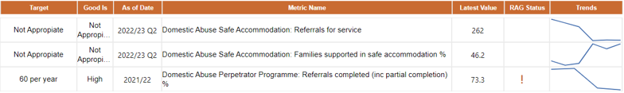**Domestic abuse**

**Safe accommodation service**

**Issue:**

* There is a fixed capacity within the system that demand currently exceeds.

**Causes:**

* Victims with complex needs take longer to recover, restricting capacity of the service.
* A lack of available housing creates blockages to move victims out of refuge, therefore restricting capacity.

**Actions:**

Strategically we are working to reduce demand for this provision and increase capacity within the service through:

* Developing other support options for domestic abuse victims in the community and investing in preventative support e.g., outreach.
* Supporting services to increase flowthrough through resettlement, therefore creating more available capacity.

**Adult Perpetrator programme**

There are no national targets for this KPI as it is a local voluntary programme aimed at heterosexual adult males, although we do set local targets accordingly.

**Issue:**

* The service is not currently able to meet the local annual target of 60 completers due to a 70% decrease in referrals (reduction from 154 in 2020/21 to 46 in 2021/22).

**Causes:**

* The impact of the Covid pandemic on the service.
* The successful introduction of the family safeguarding model within LCC which provides interventions directly for perpetrators has now led to a corresponding reduction in referrals from the family safeguarding team but which now offers an opportunity to develop referrals further from other services

**Actions:**

* To achieve our local target, a recovery plan has been developed with the service provider to increase referrals from other partners by raising awareness with a variety of statutory and voluntary organisations, including those engaged with the emerging Multi-Agency Risk Reduction Assessment Coordination approach to domestic abuse.
* We will conduct continual scrutiny of the service data to identify changes/trends earlier.
* We will obtain comparison information from across the country of those running similar perpetrator programmes to gain a better insight into the service.
* We continue to work closely with the commissioned services supporting domestic abuse victims to support the whole family and reduce harmful behaviours.

**Substance misuse and alcohol**

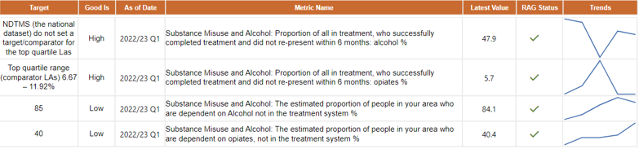

Although the KPIs for this service are on or above target, the following issues are being monitored and actively actioned as they impact both the number of people in treatment and treatment outcomes.

**Issue:**

* Limited capacity in the treatment system coupled with a need to increase referrals from partners.

**Causes:**

* Increased complexity and poorer general health of people coming into treatment having an adverse impact on outcomes and capacity.
* Impacts from the Covid pandemic causing reduced capacity.

**Actions:**

* We submitted plans to the Office for Health Improvement and Disparities (OHID). Subsequently, OHID have allocated additional investment for Lancashire through the Supplemental Substance Misuse Treatment and Recovery Grant. In 2022/23 this amounts to £2,584,279.
* The plans will allow us to increase the quality of key working and case management by recruiting and training additional workers to reduce caseload sizes, enhance caseload segmentation approaches, increase clinical supervision, and provide training and development for new and existing staff.
* Our plans target individuals in underrepresented groups to bring them into treatment. We have developed dedicated interventions with partners in Primary care, hospital-based services, the criminal justice system, housing services and the recovery community.
* We are working with partners and our treatment and recovery services to rectify the situation whereby referrals from parts of the broader health and social care system have remained below expected levels. We have included the issues of referrals and engagement with partners as part of our submitted plans.
* The terms of the grant state that we must improve the treatment outcomes and increase the number of people in treatment by 20% (based on 2021/22 data) by 2025, phased over three years. In year one we need to draw in an additional 192 people into the treatment system.